**Homework (Simulation) Wan Huzaifah bin Wan Azhar**

In this homework, you’ll measure the costs of a system call and context switch. Measuring the cost of a system call is relatively easy. For example, you could repeatedly call a simple system call (e.g., performing a 0-byte read), and time how long it takes; dividing the time by the number of iterations gives you an estimate of the cost of a system call.

**Answer:**

1. Measuring the cost of system call

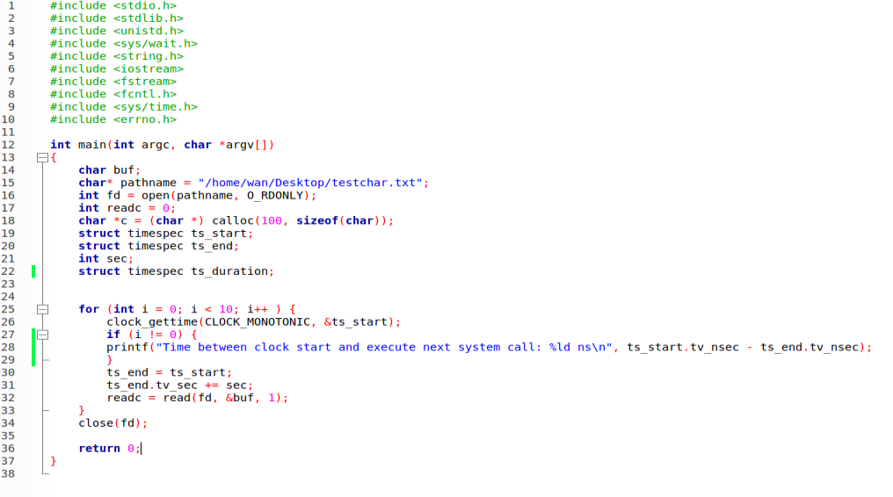

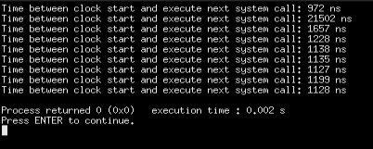

System calls take around 1000 ns.

Without system call (read() ):

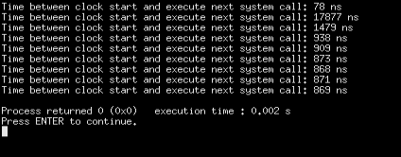

The process’s loop take less than 1000ns to execute. Therefore, read() adds around 300ns to normal procedure call.

1. Measuring the cost of context switch